Level 1

Samikri barmaja

For learn basic python

Lesson(introduction)

**Python: -**  is a popular programming language. It was created by Guido van Rossum, and released in 1991.

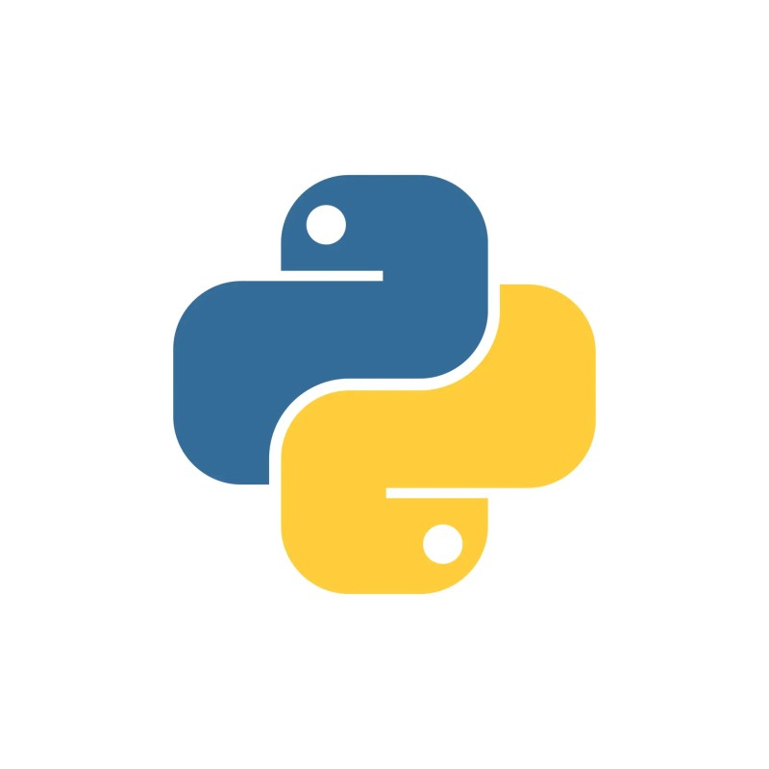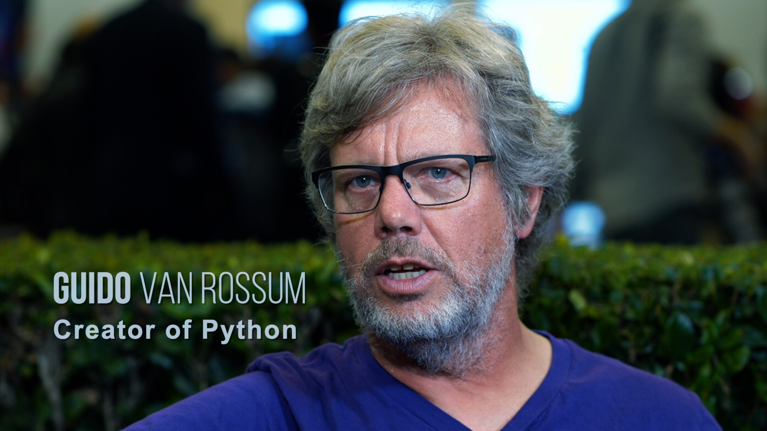

Logo python Guido van Rossum

**Why python?**

* Easy to learn and use
* Supports procedural, object-oriented or Functional programming
* Perfect for complex and quick projects

### What can Python do?

* Python can be used on a server to create web applications.
* Python can be used alongside software to create workflows.
* Python can connect to database systems. It can also read and modify files.
* Python can be used to handle big data and perform complex mathematics.
* Python can be used for rapid prototyping, or for production-ready software development.

Lesson 1

Print()

**Print ():** function to print the message

Note: - the message can be a (string, number, Boolean, list, Ist…)

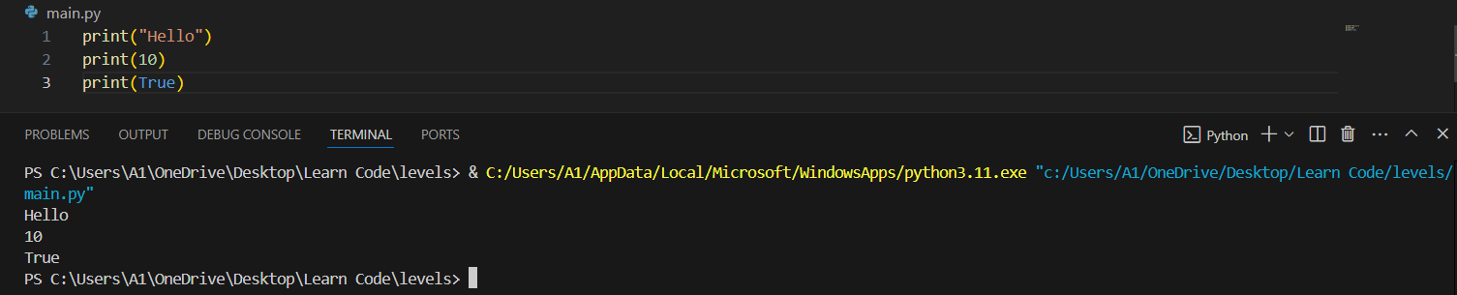

You can add multiple message in the same function via (+) or (,) like:

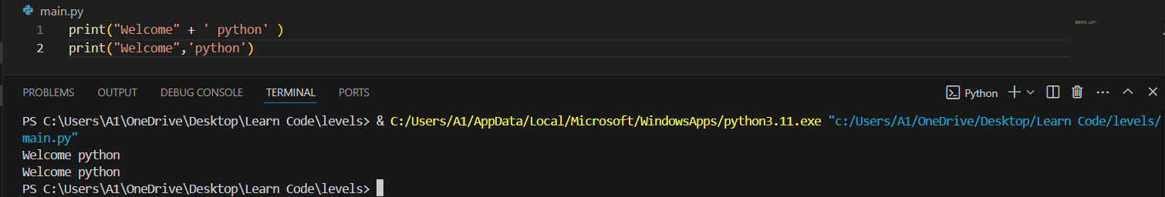

You can create multiple lines in the same message via (\n) or (‘’’) like:

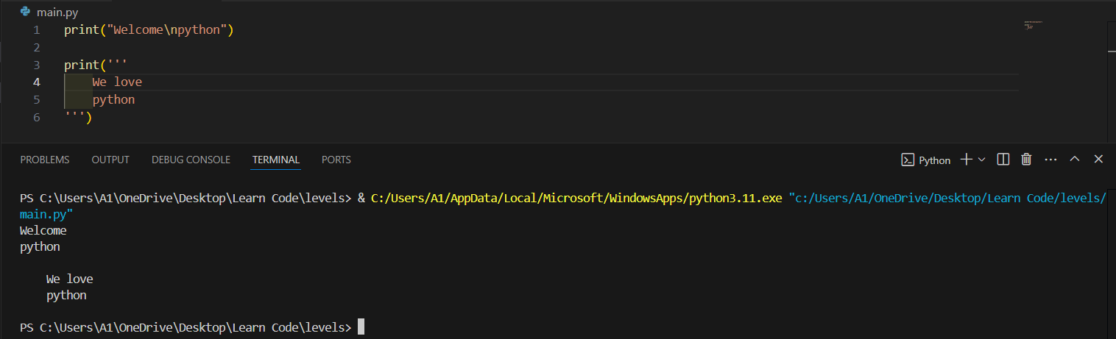

Finish the lesson

Lesson2

Input()

**Input ():** function allows user input.

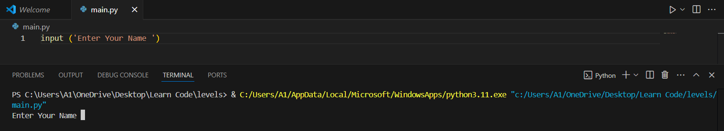

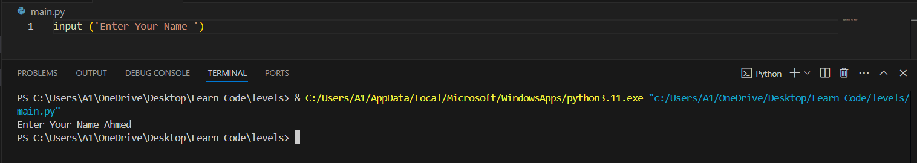

You can use the signs like (+ / , / \n) in the function

Finish the lesson

Lesson3

Variable

**Variable:** containers for storing data values.

To create a variable you can just write a name of a variable like:

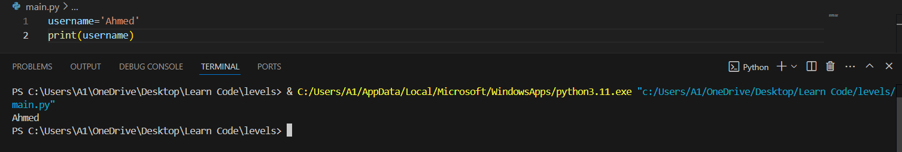

the variable name must begin with a name and be text, not a number, and there must be no spaces in the variable name that you can replace (_) but you must be no begin the any number to create a variable like:

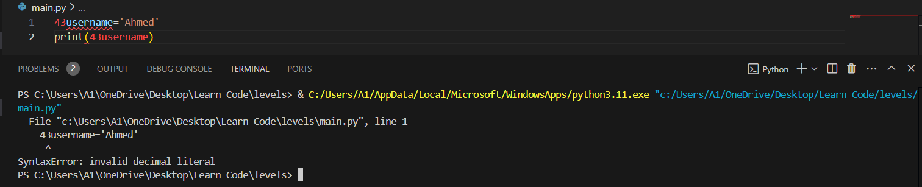

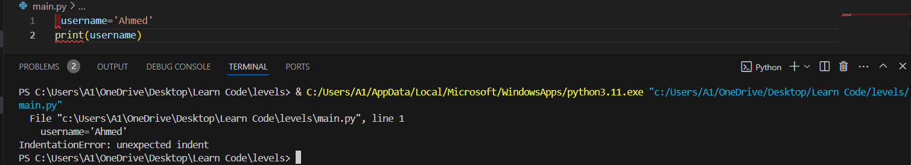

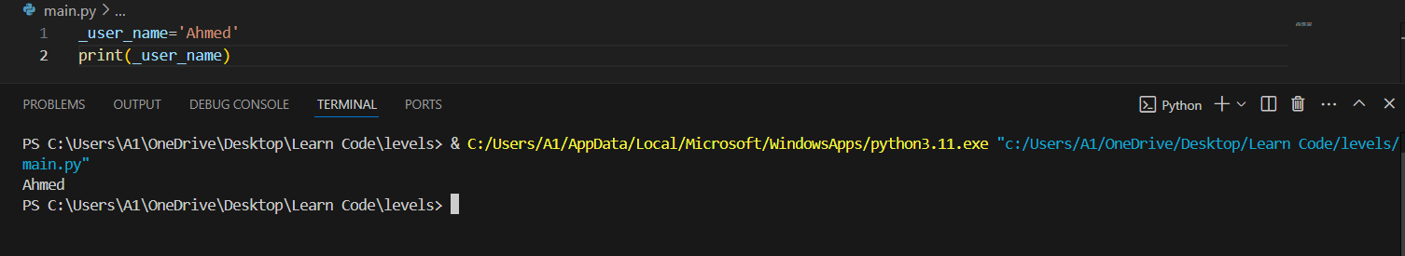

But you can add the number in the center variable name or in the end like:

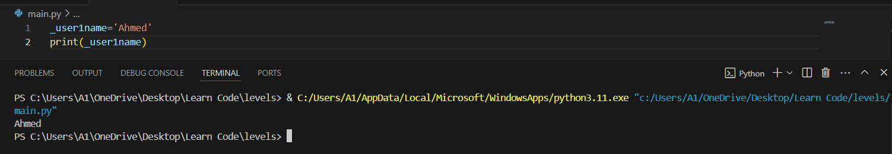

Data types:

1. String
2. integer
3. Boolean
4. Float
5. List
6. Tuple

To know data type via variables you should use (type()) like:

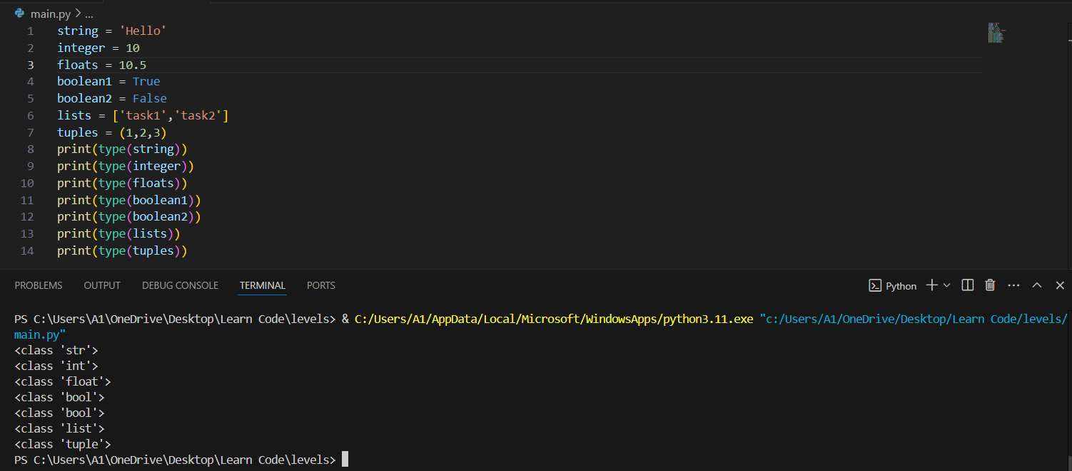

Casting:

(str()): conversion to string

(int()): conversion to integer

(float()): conversion to float

Lesson4

Operators part1

**Operators:** are used to perform operations on variables and values.

1. **Arithmetic operators:**  are used with numeric values to perform common mathematical operations like: [+, -, /, *, %, **, //]

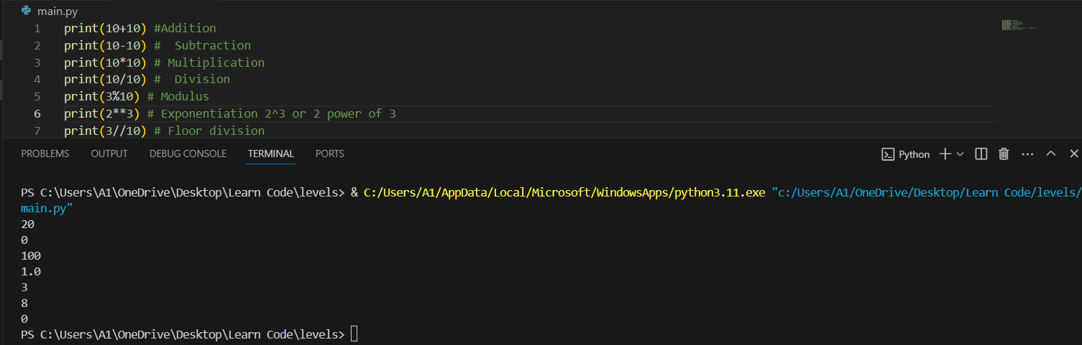

1. **Assignment:** are used to assign values to variables like:

[=, +=, -=, *=, /=, %=, **=, //=]

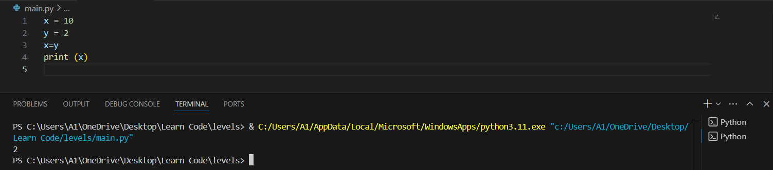

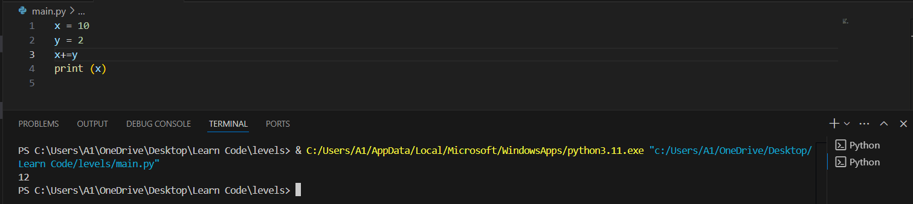

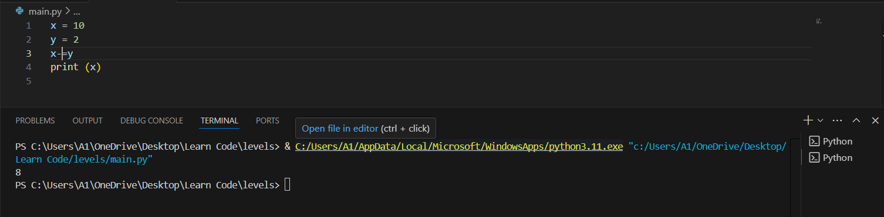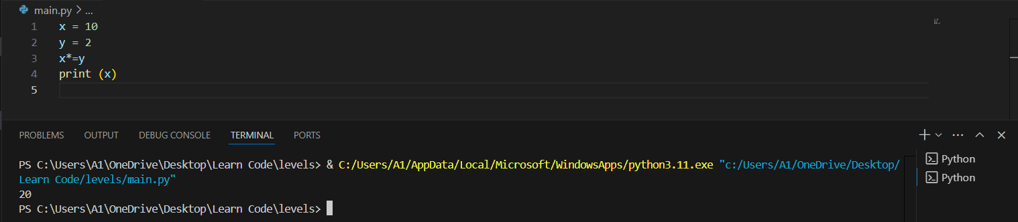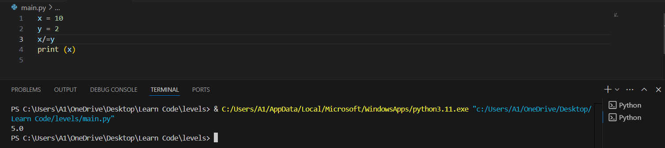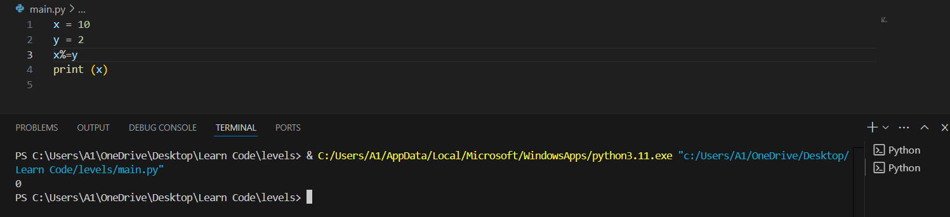

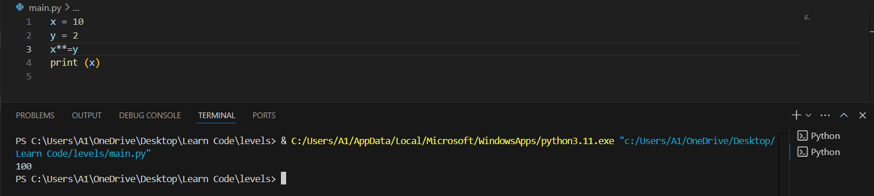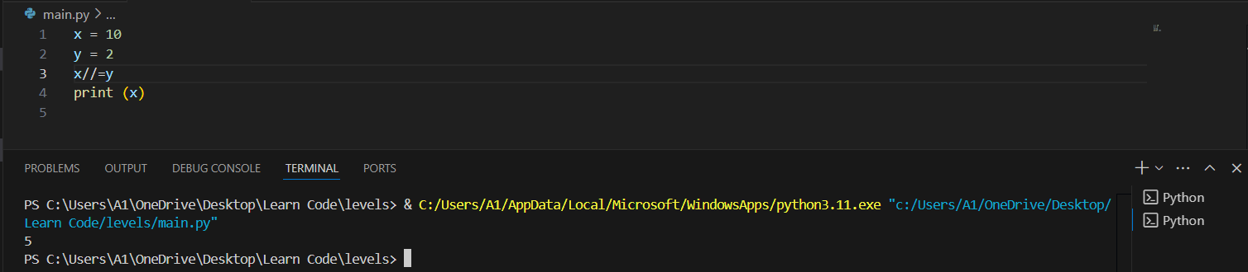

Finish the lesson

Lesson5

(Project)

This is final level: you require to create this is project: -

(You are required to create two entries. When the user enters number 1 and number 2, the program prints number 1 + number 2.)

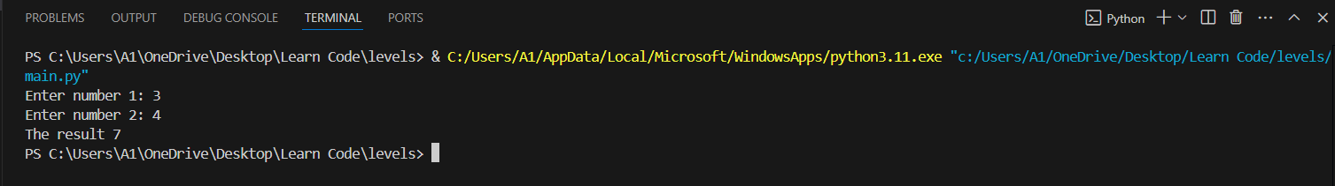

Finish the level